**Practical-6**

1. **AIM:-** Demonstrate Class, Properties, Methods, and Objects

**Code:-**

const prompt=require('prompt-sync')();

class Phone{

    constructor(model,price,date)

    {

        this.model=model;

        this.price=price;

        this.date=date;

    }

    getDetails()

    {

        console.log("model:"+this.model);

        console.log("price:"+this.price);

        console.log("Date:"+this.date);

    }

}

let model=prompt('')

let date=new Date() ;

let phone=new Phone(model,"$2500000",date.getFullYear()+"-"+date.getMonth()+1+"-"+date.getDate());

phone.getDetails();

**Output:-**

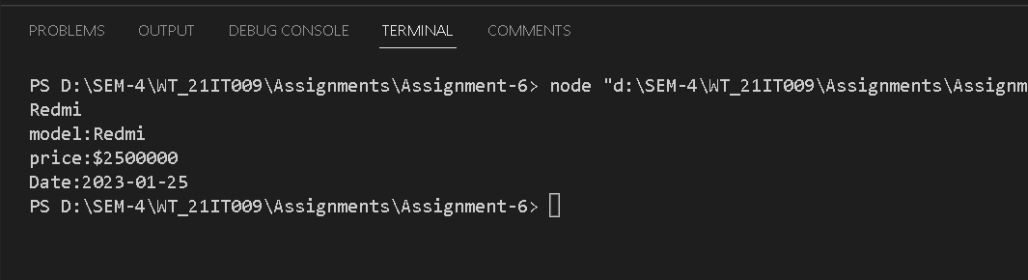

**Conclusion:-**

From this practical, I learned about the date object and class in JavaScript. Using the object, We can easily work with the file and also create the object using the inbuilt class easily.

1. **AIM:-** Demonstrate how to work with JSON File

**Code:-**

<!DOCTYPE html>

<html>

  <body>

    <h2>This will be the response from server:</h2>

    <p id="demo"></p>

    <script>

      let text =

        '{"employees":[' +

        '{"firstName":"John","lastName":"Doe" },' +

        '{"firstName":"Anna","lastName":"Smith" },' +

        '{"firstName":"Peter","lastName":"Jones" }]}';

        let text2 ='{"firstName":"xyz","lastName":"abc","id":"IT123","ResponseSubmitted":"True","Marks":"100"}';

      const obj = JSON.parse(text2);

      document.getElementById("demo").innerHTML =

        "Name:"+obj.firstName + " " + obj.lastName+"<br>Summitted:"+obj.ResponseSubmitted+"<br>Marks Obtained :"+obj.Marks;

    </script>

  </body>

</html>

**Conclusion:-**

From this practical, I learned how to work with JSON files and objects. Also, know how to create the JSON file and create JSON objects.

1. **AIM:-** Do Spoural Registration Form Validation (Error object and try…catch..)

**Code:-**

**HTML Code:-**

<!DOCTYPE html>

<html lang="en">

<head>

    <meta charset="UTF-8">

    <meta http-equiv="X-UA-Compatible" content="IE=edge">

    <meta name="viewport" content="width=device-width, initial-scale=1.0">

    <title>Registration form</title>

</head>

<body>

    <h3>The Events happen in Charusat University in Spoural.</h3>

    <ol>

        <li>Sport Activities</li>

        <li>Cultural Activities</li>

        <li>Student Hackthons</li>

        <li>Exhibinations</li>

        <li>Many Games</li>

    </ol>

    <h4>Fill this form and submit it to take part in Spoural 2023.</h4>

    <form action="Home.html" method="post">

        <label for="First Name">First Name</label>

        <input type="text" name="First Name" id="First Name" placeholder="First Name">

        <br>

        <label for="Middle Name">Middle Name</label>

        <input type="text" name="Middle Name" id="Middle Name" placeholder="Middle Name">

        <br>

        <label for="Last Name">Last Name</label>

        <input type="text" name="Last Name" id="Last Name" placeholder="Last Name">

        <br>

        <label for="Father's Name">Father's Name</label>

        <input type="text" name="Father's Name" id="Father's Name" placeholder="Father's Name(Full)">

        <br>

        <label for="Number">Contact Number</label>

        <input type="number" name="Number" id="Number" placeholder="Your Mobile Number">

        <br>

        <label for="textarea" aria-placeholder="Your address">Address</label>

        <br>

        <textarea name="Textarea" id="textarea" cols="30" rows="5" placeholder="Your Address"></textarea>

        <br>

        <label for="College Name">Your College</label>

        <input type="text" name="College Name" id="College Name" placeholder="Your College Name">

        <br>

        <label for="Branch">Branch</label>

        <input type="text" name="Branch" id="Branch" placeholder="Your Branch">

        <br>

        <label for="Year">Current Year</label>

        <input type="number" name="number" id="Year" placeholder="Current year">

        <br>

        <label for="Email">Email ID</label>

        <input type="email" name="Email" id="Email" placeholder="Your Email ID">

        <h3>Note: If your not the student of Charusat then Please Provide the personal email id.</h3>

        <h3>If you are the student of Charusat University then fill out the information given below.</h3>

        <label for="ID">ID Number</label>

        <input type="text" name="ID" id="ID" placeholder="Charusat's student ID">

        <br>

        <br>

        <button type="submit" onclick="Vald()">Submit</button>

        <input type="reset" value="Reset">

        <br>

        <!-- <a href="Spoural_Event_Home.html">Home Page</a> -->

    </form>

    <Script src="./prac6.js"></Script>

    <h4>copyright&nbsp;&copy;&nbsp;2022-2023</h4>

</body>

</html>

**JavaScript Code:-**

/*

    function displaySelectedValue() {

    const selectedValue = document.querySelector('input[name="color"]:checked').value;

    const selectedValueEl = document.getElementById("selectedValue");

    selectedValueEl.innerHTML = "Selected Value: " + selectedValue;

}

*/

function Vald()

{

    const selval=document.querySelector('input[name="branch"]:checked');

    /*if(selval==null)

    alert(selval);

    else

    alert("branch="+selval);*/

    const id_val=document.getElementById('StudentID');

    //alert((id_val.value==""));

    const contact_no=document.getElementById('contactNumber').value;

    //alert(contact_no);    contactNO ==""  Institute       semester ===""

    const Inst=document.getElementById('Institute').value;

    const sem=document.getElementById('semester').value;

    try{

            if(id_val.value=="")

            {

                throw "ID INVALID!";

            }

            else if(selval==null)

            {

                throw "Branch Not selected";

            }

            else if(contact_no=="" || Inst=="" || sem=="")

            {

                throw "there are empty fields";

            }

            else{

                document.write("Successfully submitted !");

            }

    }

    catch(err)

    {

        alert(err);

        cancelFormSubmission();

    }

    finally{

    }

}

**Output:-**

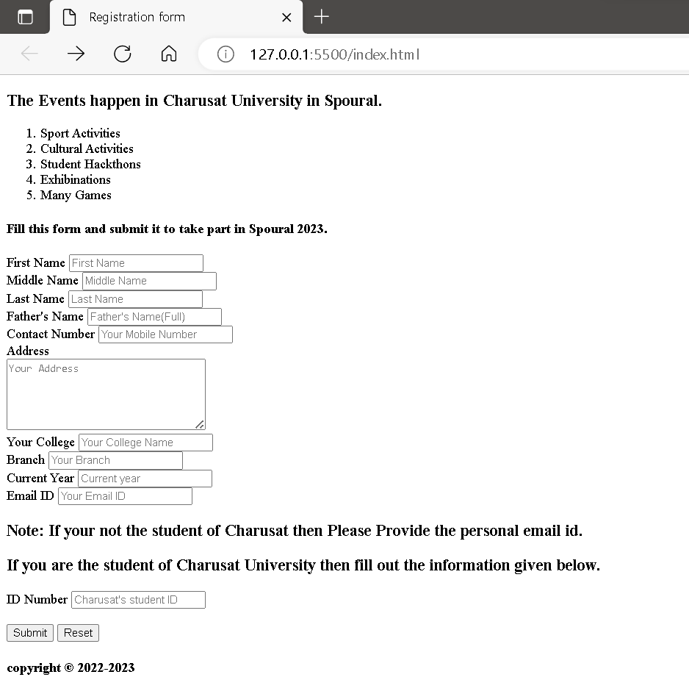

**Conclusion:-**

From this practical, I learned how to create the object in JS and how to create and handle errors in JS.